### Alarm Settings

Here you can specify different alarm settings.

Under “Duty Alarm System” you can choose the following:

Automatic deactivate of public space When ER attended: if you do not want the alarms to sound in all the public spaces when there is someone at watch in the ER

Alert duty Cabin When ER turns unattended: To notify the person on duty that there is nobody in the ER anymore and his watch begins.

Alert Bridge when ER turns unattended: Just for convenience.

Under “Personal Alarm Settings” you can choose if the deadman timer starts again with every new alarm.

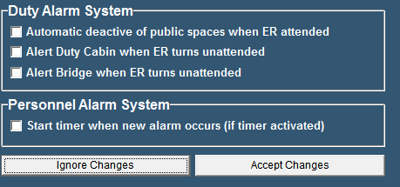

Figure 12‑8: Alarm Settings